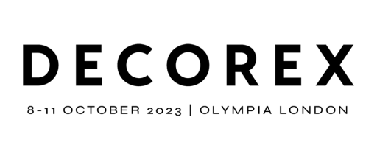
Exhibitor PR Factsheet
Please complete and return to Decorex@wildwoodpr.com as soon as possible
The information you provide will be used within the Decorex 2023 PR campaign. Please also provide the following:
- Up to 4 high-res product & lifestyle images illustrating exhibiting products/ranges
- Company logo
- Video footage showcasing products, craftsmanship, showroom or brand (if available)
Exhibitor Name

Website

Social Media Handles

PR / Marketing Contact
(name / email / tel no.)

Company Profile Summary:

Key areas of business, products and/or services?

New products launching at Decorex?

(name of product & bullet point key features. Include any embargo details)

Details of any other products you are exhibiting at Decorex?

How is your brand sustainable?

We’d love to know how you operate in a sustainable way (your business practices, sourcing, products, work with charities etc)
Any additional promotional activities?

(Demos / special guests / talks on your stand)

Please confirm you consent to the use of the information included on this fact sheet for PR purposes | Yes / No

In addition, we will also be creating a Digital PR space for Decorex 2023 Digital Press Kits. When advised, you will be able to upload press content (including company press releases and images), ready for the link to be shared with press on the first day of the show.

